Doyoubuzz clone:
Kindly check the page wise functionality work. If you have any comments please let me know.
Well, the object is clone Doyoubuzz, so we hope have the same functionalities
Home page:
- Logo
- Sign in, create account options
Features:
- List of features in this site.

Career advice:
  - Find job.
  - Get a great resume.
  - Manage your career.
  - Tag cloud.
  - Comment post
  - Reply for comment post.
  - Social sharing.
Blog:
- List of blog.
- Comment for blog.
- Reply for comment blog.
- Social sharing.
Static pages:
- F.A.Q
- Contact us.
- Partners.
- About us
- Term of service.
- Privacy policy.

After user login:

Dashboard:
- Resume completion.
- Resume views.
- Recommendations.
- List of newly added resumes.
- Newsletters.

My resume:
- Add content.
- Essentials: (It’s the most important part, we want it at least 95% similar as DoyouBuzz)
And we like his toolbar, so we hope to have a similar one
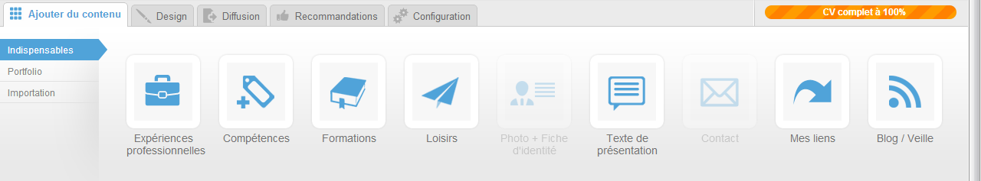
  - Professional experience
  - Skills
  - Education
  - Interests
  - Photo and basic info
  - About me
  - Contact
  - My links
  - Blog
  - “New Field” which should allow user to add one or several free zones where he can give a title and put whatever text he want
- Portfolio:
  - Photo
  - Video
  - Audio
  - Word / Pdf
  - Presentation
- Import:
  - Linkedin.

Design:
- Themes. – (How many themes do you want? 4 will be enough for now, we can pay u for some more in later?)

Share:
- Social share.
  - Facebook.
  - Twitter.
  - Linkedin.

Recommendation:

Setting:
- General
- Privacy
- Resume url
Download:
- PDF.
- Word.
User setting:
- Personal information.
- Change password.

